**1. Reading Assignment: A Short History of Java**

* **Task**: Read about the history and development of Java.  
    
  =>1)java project started from “The green project” at sun microsystems and lead by James Gosling, Mike Sheridan, and Patrick Naughton   
  2)initially name was “Oak” then change to java due to trademark issue  
  3)first introduce java in 1995  
  4)slow gun is “Write once run anywhere”(WORA)  
  5)first version of java is 1.0  
  6)in 1996 jdk version 1 was released  
  7)then after in 1998 java 2 was released and the platform divided into 3 parts
* java standard edition(J2SE)
* Java Enterprise edition(J2EE)
* Java Micro Edition(J2ME)
* **Link**: http://sunsite.uakom.sk/sunworldonline/swol-07-1995/swol-07-java.html

**2. Reading Assignment: Java Language Features**

* **Task**: Learn about the main features of Java.  
  1)Simple  
  2)Robust  
  3)Secure  
  4)Object oriented  
  5)portable  
  6)dynamic  
  7)Platform independent
* **Link**: https://javaalmanac.io/features/

**3. Reading Assignment: Which Version of JDK Should I Use?**

* **Task**: Find out which JDK version is right for you.  
  LTS version due to long term support jdk 17 and jdk11 version are stable version
* **Link**: https://whichjdk.com/

**4. Reading Assignment: JDK Installation Directory Structure**

* **Task**: Understand the folder structure and files in the JDK installation.  
  jdk17  
   bin  
   java=> The Java runtime launcher that starts the Java application  
   javac=> The Java compiler that translates Java source code into bytecode (.class files)  
   Javadoc=>Generates HTML documentation from Java source code  
   jar=>A tool to package multiple files into a JAR (Java ARchive) file  
   conf  
   include  
   jmods  
   legal  
  lib  
   in lib there is src zip folder
* **Link**: https://docs.oracle.com/javase/8/docs/technotes/tools/windows/jdkfiles.html

**5. Reading Assignment: About Java Technology**

* **Task**: Read about the basics of Java technology and its components.
* **Link**: https://docs.oracle.com/javase/tutorial/getStarted/intro/definition.html

**6. Coding Assignments**

1. **Hello World Program**: Write a Java program that prints "Hello World!!" to the console.  
   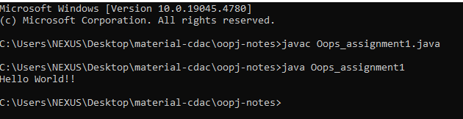
2. **Compile with Verbose Option**: Compile your Java file using the -verbose option with javac. Check the output.  
     
   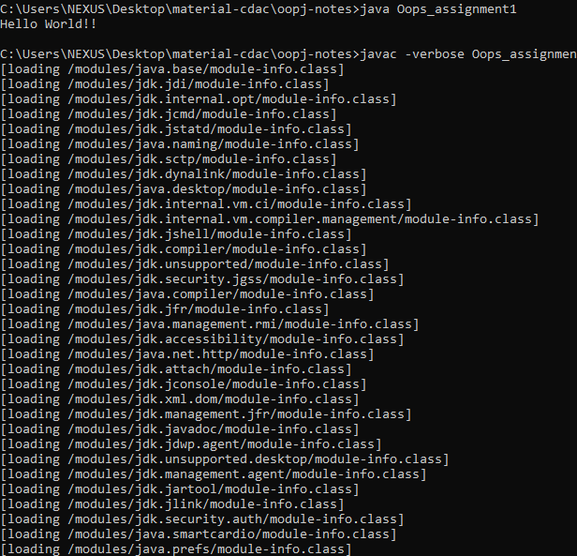
3. **Inspect Bytecode**: Use the javap tool to examine the bytecode of the compiled .class file. Observe the output.

**7. Reading Assignment: The JVM Architecture Explained**

* **Task**: Learn about how the Java Virtual Machine (JVM) works.
* **Link**: https://dzone.com/articles/jvm-architecture-explained

**8. Reading Assignment: The Java Language Environment: Contents**

* **Task**: Explore the content and features of the Java language environment.
* **Link**: https://www.oracle.com/java/technologies/language-environment.html